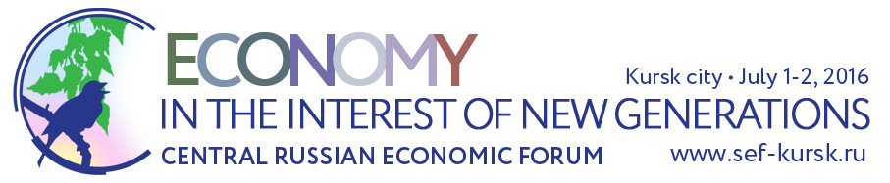

FORUM SCHEDULE

July 1
8:30-10:00 | Registration of Forum participants

9:00-10:00 | Official Forum exhibitions opening ceremony
10:00-17:30 | Opening hours of the CREATING FUTURE NOW Interregional Business Exhibition
10:00-17:30 | Opening hours of the exhibition of innovative solutions provided by young scientists
10:00-17:30 | Opening hours of the “Tourism Potential of Kursk Region” photo exhibition
10:00-17:30 | Opening hours of the “The Country I Want to Live In” children’s art exhibition

10:00-12:30 | PLENARY SESSION OF THE 5TH CENTRAL RUSSIAN ECONOMIC FORUM  Economy in the interest of new generations  Place: Kursk City Sports & Concert Complex, Ground Floor, Great Hall

12:30-13:00 | SIGNING OF AGREEMENTS Place: Kursk City Sports & Concert Complex

12:30-14:00 | Lunch time

14:00-18:00 | Thematic modules of the 5th CENTRAL RUSSIAN ECONOMIC FORUM (held simultaneously)
14:00-18:00 | MODULE 1: PUBLIC WELFARE FOR FUTURE GENERATIONS  Module events:  - Business competition of Central Russia’s investment projects: “Creating Future Now”  - Cross-industry discussion: “Strategy of creating high-technology industry of the future” / with the assistance of Russia’s Ministry of Industry and Trade /  - Strategic session: “Development of rural areas and strengthening of Russia’s food security”
14:00-18:00 | MODULE 2: SMALL AND MEDIUM-SIZED BUSINESSES IN THE NEXT ECONOMY  Module events:  - Round table moderated by Russia’s Ministry of Economic Development / with the assistance of Russia’s Ministry of Economic Development and JSC Russian Small and Medium Business Corporation /
14:00-18:00 | MODULE 3: YOUTH SHAPES THE FUTURE  Module events:  - Strategic session for youth “My role in the development of the next economy: projects, teams, leaders” / with the assistance of the Institute for Economic Strategies and the “Analytics” Association of assistance to development of the analytical potential of the human, society and state /  - Presentation of promising projects and solutions of young researchers and entrepreneurs of Central Russia
14:00-18:00 | MODULE 4: ENVIRONMENT  Module events:  - Open dialogue: “The city I want to live in” / with the assistance of Russia’s Chamber of Commerce and Industry, PPP Development Center, Russia’s Ministry of Economic Development, the government of Kursk city /  - Round table: One stop system. optimization of interaction between the state machinery and the business community / with the assistance of the multiservice center for state and municipal services of Kursk region /
14:00-18:00 | MODULE 5: HEALTH OF THE NEXT GENERATION  Module events:  - Round table: Integration of public healthcare, education, physical training and sports as a public health maintenance factor / with the assistance of Russia’s Ministry of Sports, Ministry of Health and the All-Russian Public Organization “Public Health League” /
14:00-18:00 | MODULE 6: CULTURAL HERITAGE  Module events:  - Round table: “Preservation and accumulation of cultural heritage for future generations”
July 2
10:00-11:00 | 16th KURSK KORENSKAYA FAIR 2016  OFFICIAL OPENING CEREMONY
11:00-18:00 | KURSK KORENSKAYA FAIR OPEN  / Main exhibition hall, Industry, Small & Medium-sized businesses, Food and food-processing industry, Agriculture, Construction, Banks and Insurance Companies, Regions of Central Russia, Regions of Russia /

12:00-17:00 | EXCURSION PROGRAM for Forum guests

